Exp 4: Combinational Circuit Design

Engineering 357 - Digital Design Lab

Fall 2015

Farnam Adelkhani

Date Experiment Performed: 9-29-2015

Date Report Submitted: 10-1-2015

Farnam Adelkhani

Engineering 357 - Digital Design Lab – 9/29/15

Experiment #4

**Exp. 4 Combinational Circuit Design**

**Abstract and Objective:**

The general objective and purpose of this lab assignment is to gain further familiarity with the process of conceiving, planning and laying out a solution regarding the creating and formulation of a digital circuit design. We must begin by fully understanding the problem at hand, after the problem is thoroughly understood then we can identify the inputs and outputs of the circuit we are designing. Once the inputs and outputs are identified we can use the know relationships to represent the data in a truth table or Boolean equation.

The two methods of translating a combinational logic problem into a model are first; the method for a small circuit, constructing a truth table in which all the possible input combinations are listed. The second method is to translate the problem statement into mathematical models to express input-output relationships directly in Boolean algebra form. Sometimes the second method makes for an easier and more natural interpretation of the problem.

**Components Used:**

* Xilinx software on PC
* The following gates/integrated circuits:
* 74LS00
* 74LS04
* 74LS08
* 74LS32
* 74LS86A

**Procedures and result:**

1. This experiment was started at home by completing the pre-lab assignment which included 4 questions. The goal of each question was essentially to come up with the expressions that satisfy the implied problem given to us. In problem #1 we are given a four-bit binary number representation and its grey code. We are asked to design a circuit to convert the binary values into grey code. It is also advised to the experimenter do so using XOR gates. Ultimately, the logic diagram included 3 XOR sharing the 4 inputs and outputting G0,G1,G2 and G3 .
2. The next problem statement wants the experimenter to create a three-way light control. We are to design a switching circuit that can turn a light on and off from three different switches. For this problem a truth table was setup and filled out in accordance with the given rules. We are to find the output given the information we need to determine its value at each given combination of inputs. This problem was solved by creating a k-map from the input data and using that map to come up with the simplified expression that will give us our logic diagram.
3. In problem #3 the designer is asked to create a voting machine for 5 users. One of the users however, is the chairman and she/he has veto power. In other words, the motion is only passed if two of the voters B-E agree with the chairman (A). The statement used to find our logic diagram in this problem was F=A{BC + (B + C)(D + E) + DE}, which was obtained from a k-map.

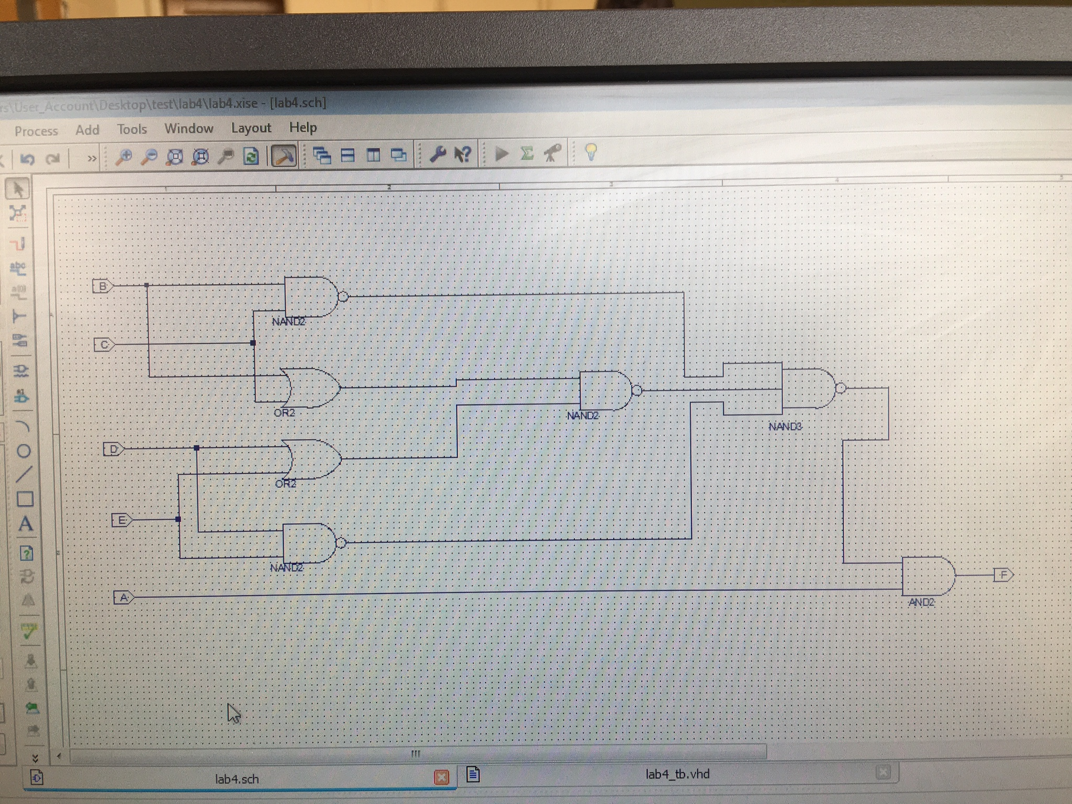

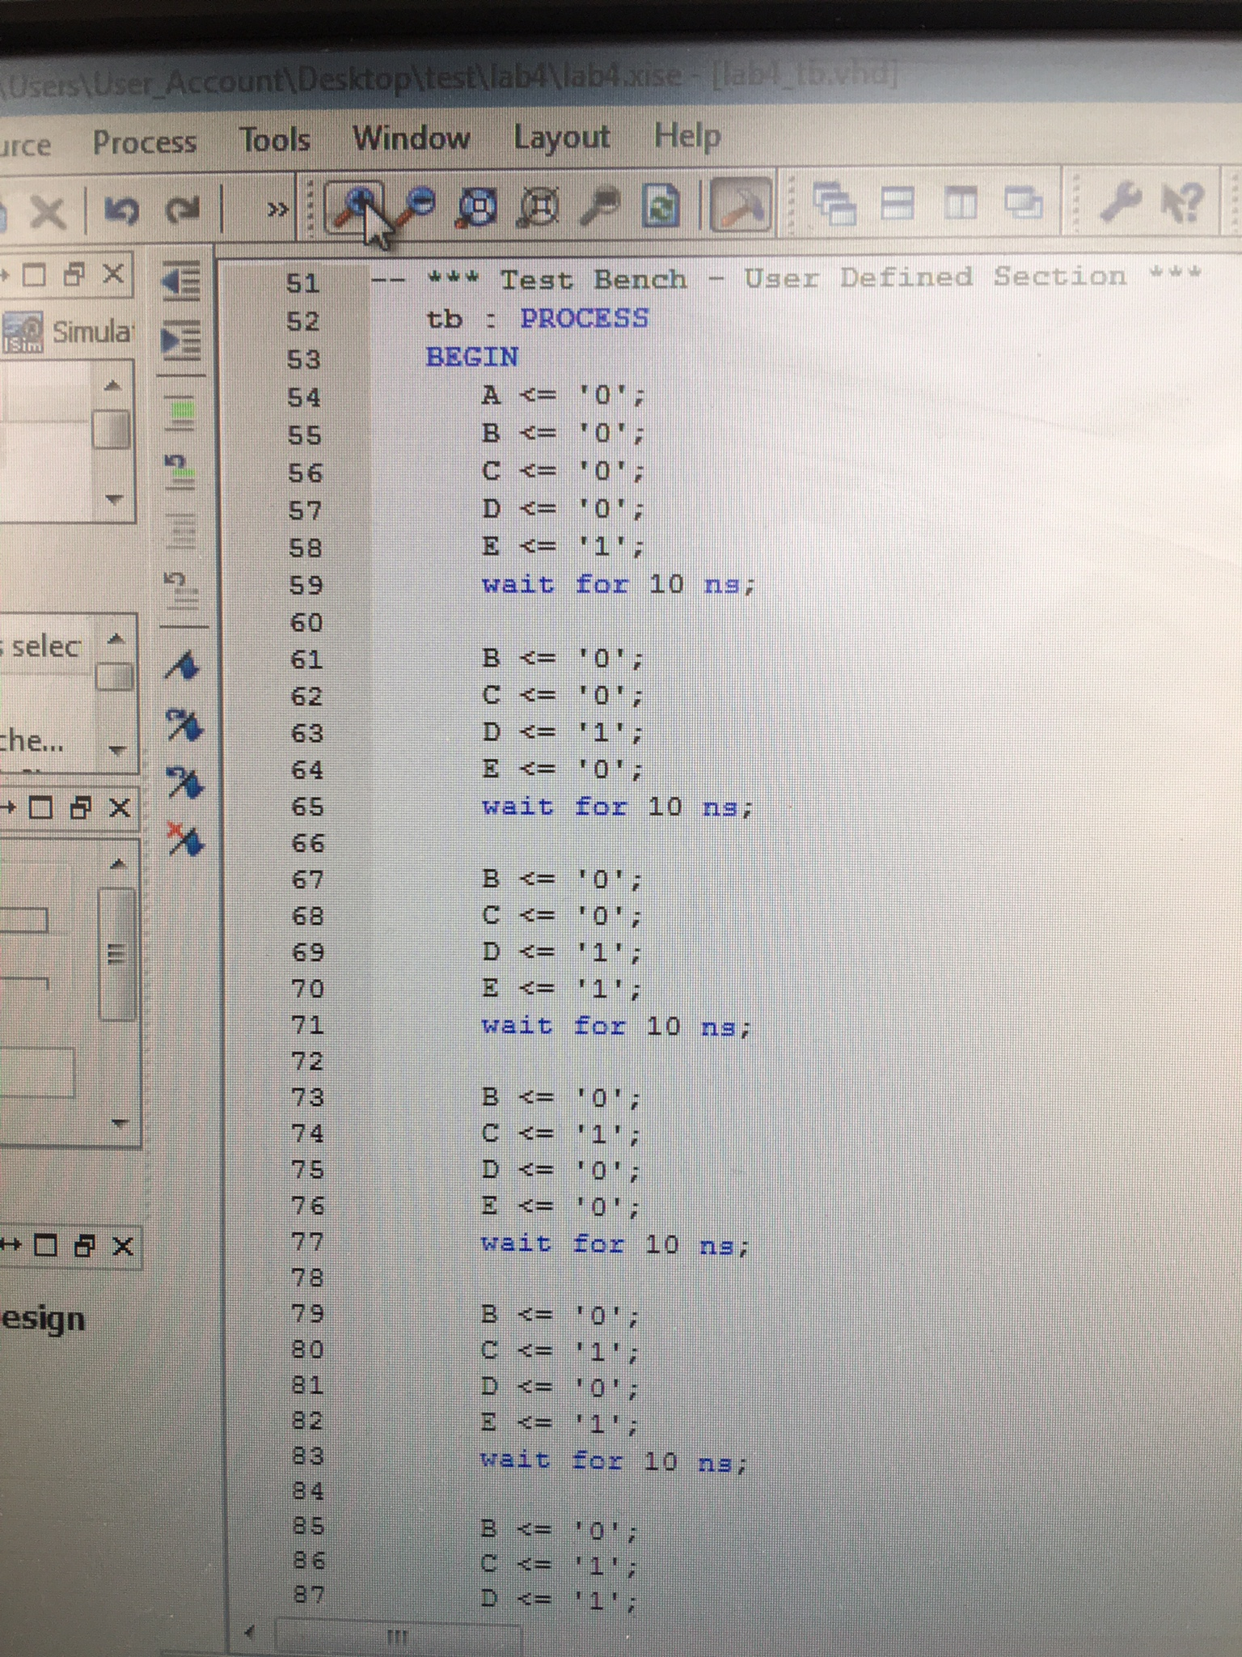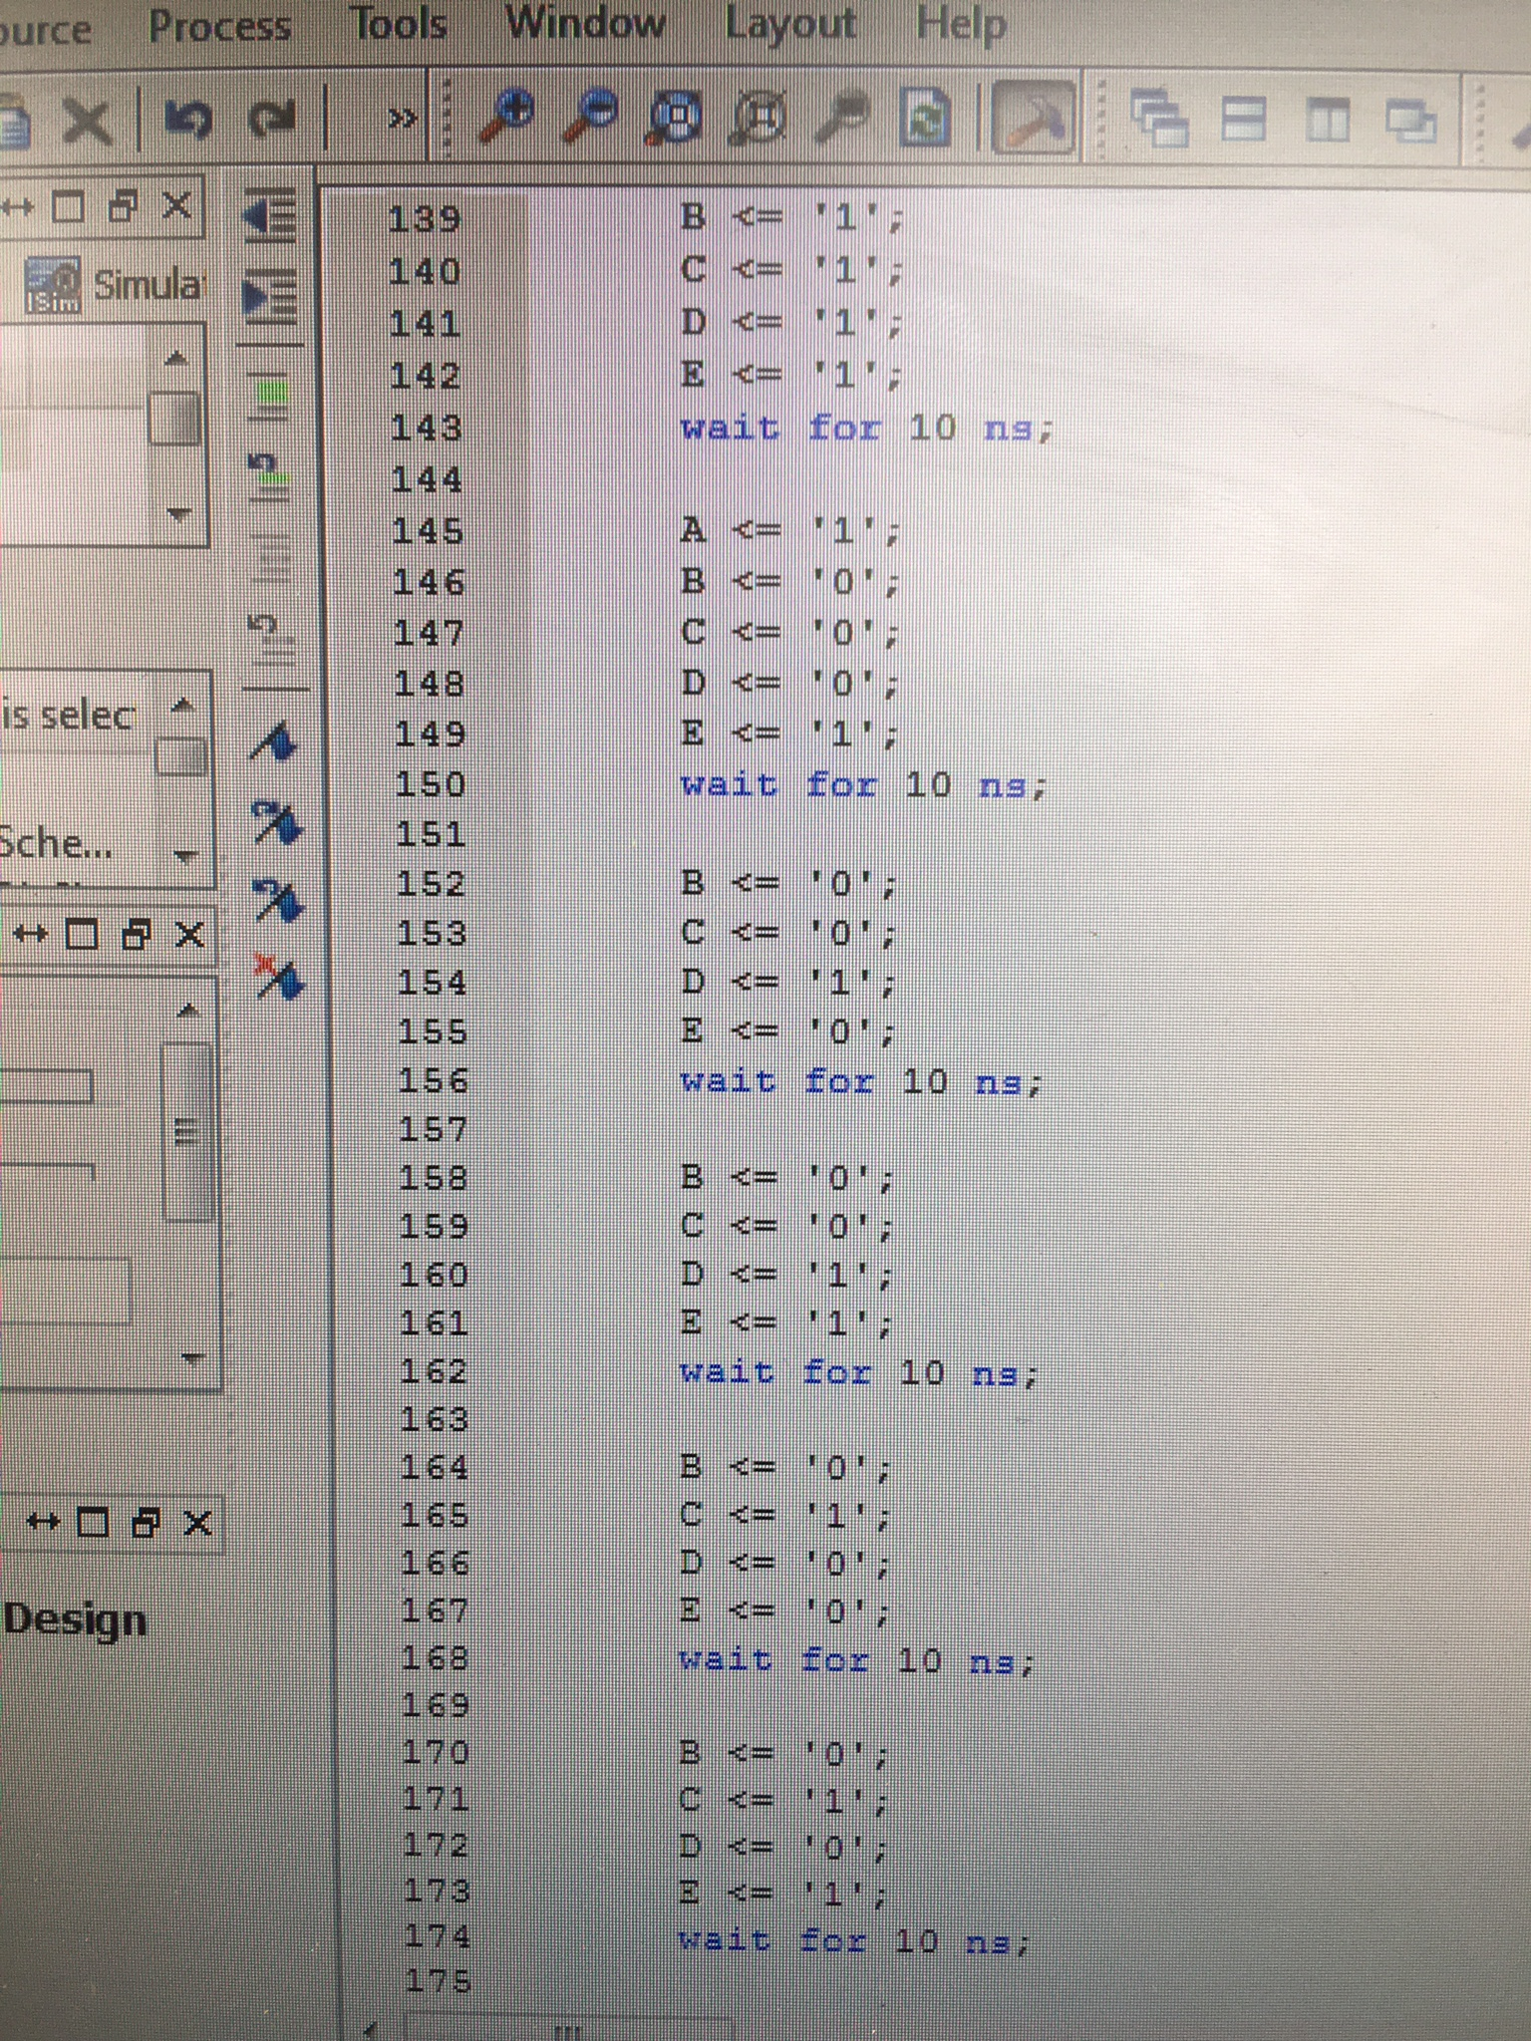

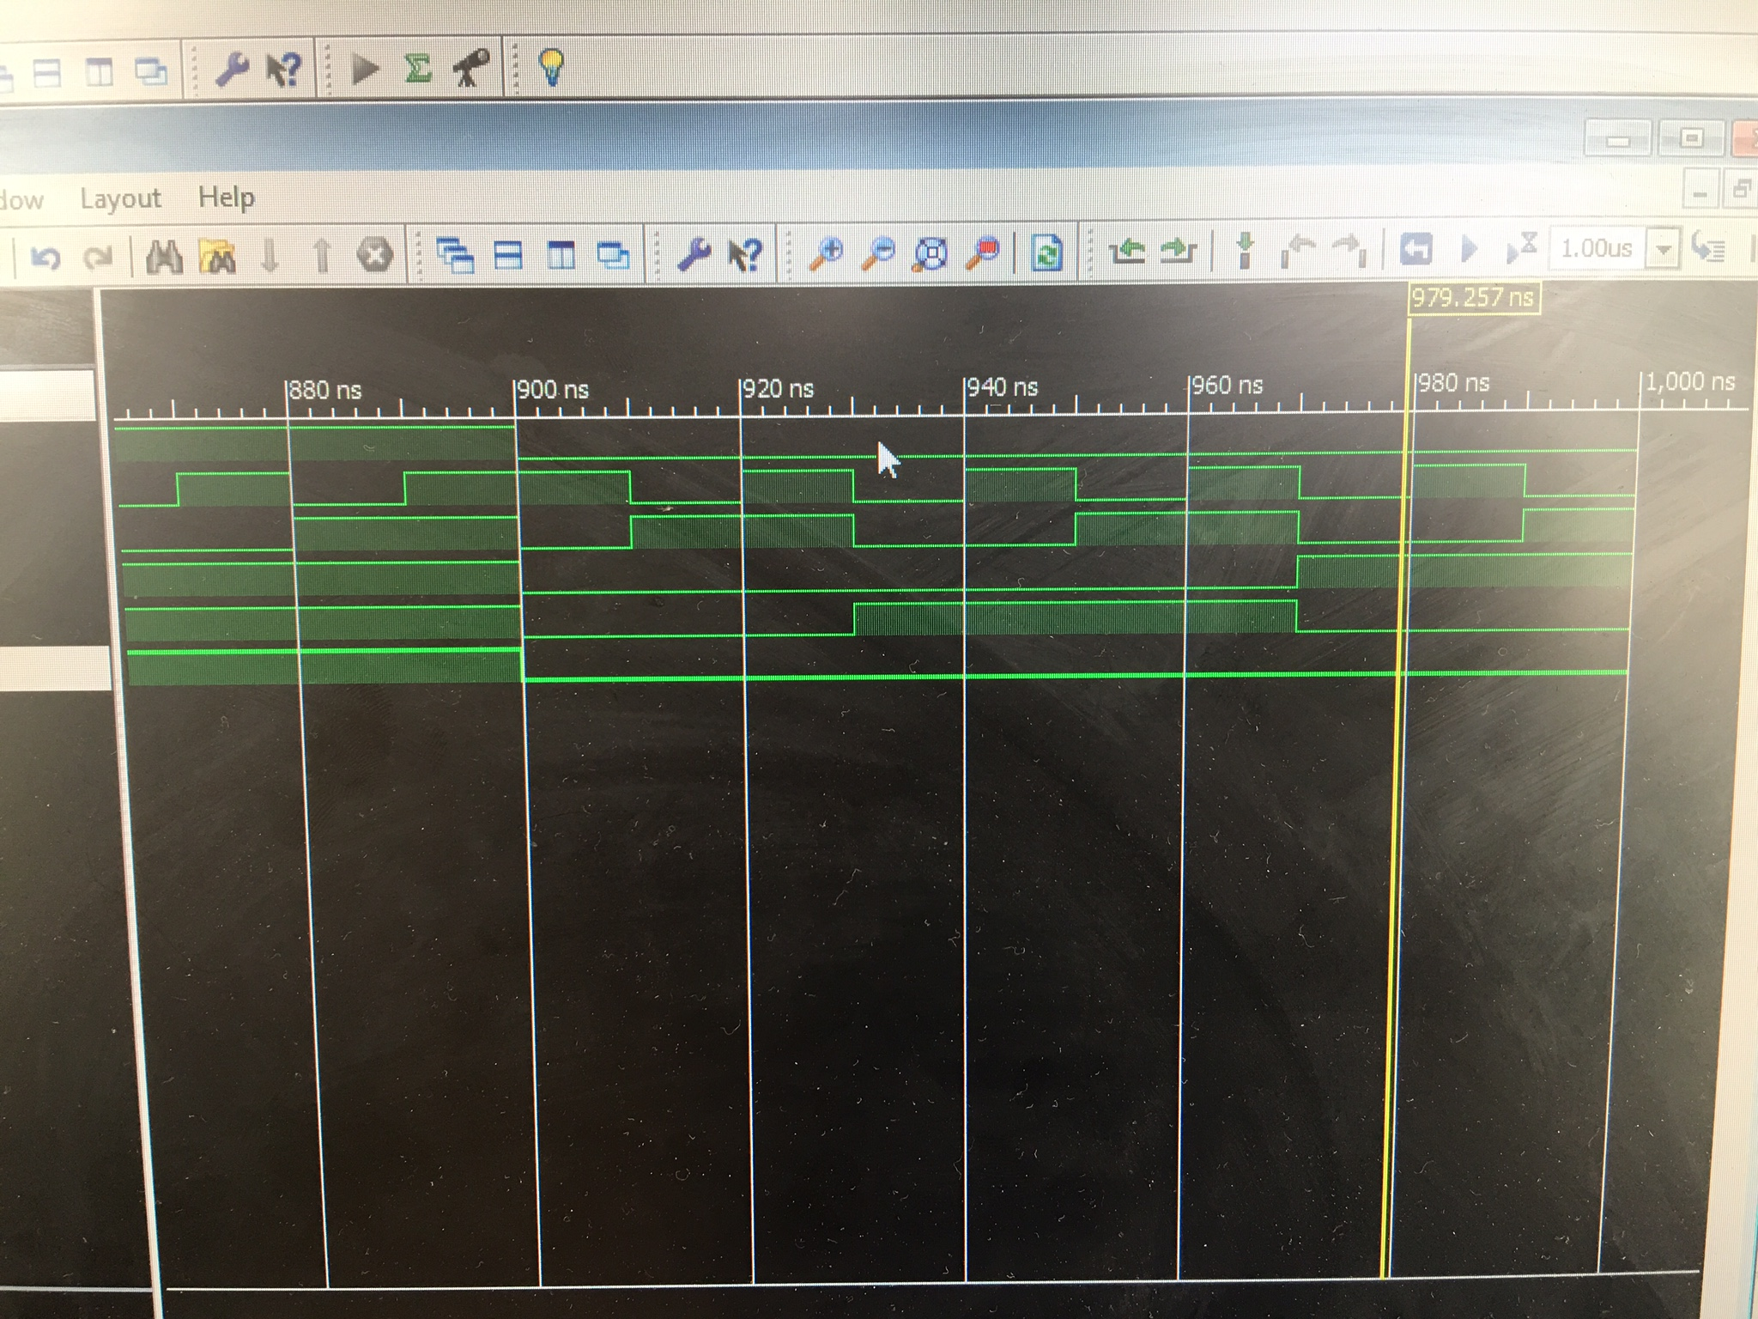

1. The last problem statement given to us is #4 which asks to create 3 different logic diagrams base on the data given in the table. We then are construct our logic diagram in Xilinx and map the outputs. We confirm that the desired outputs are being conveyed for each of the logic circuits.

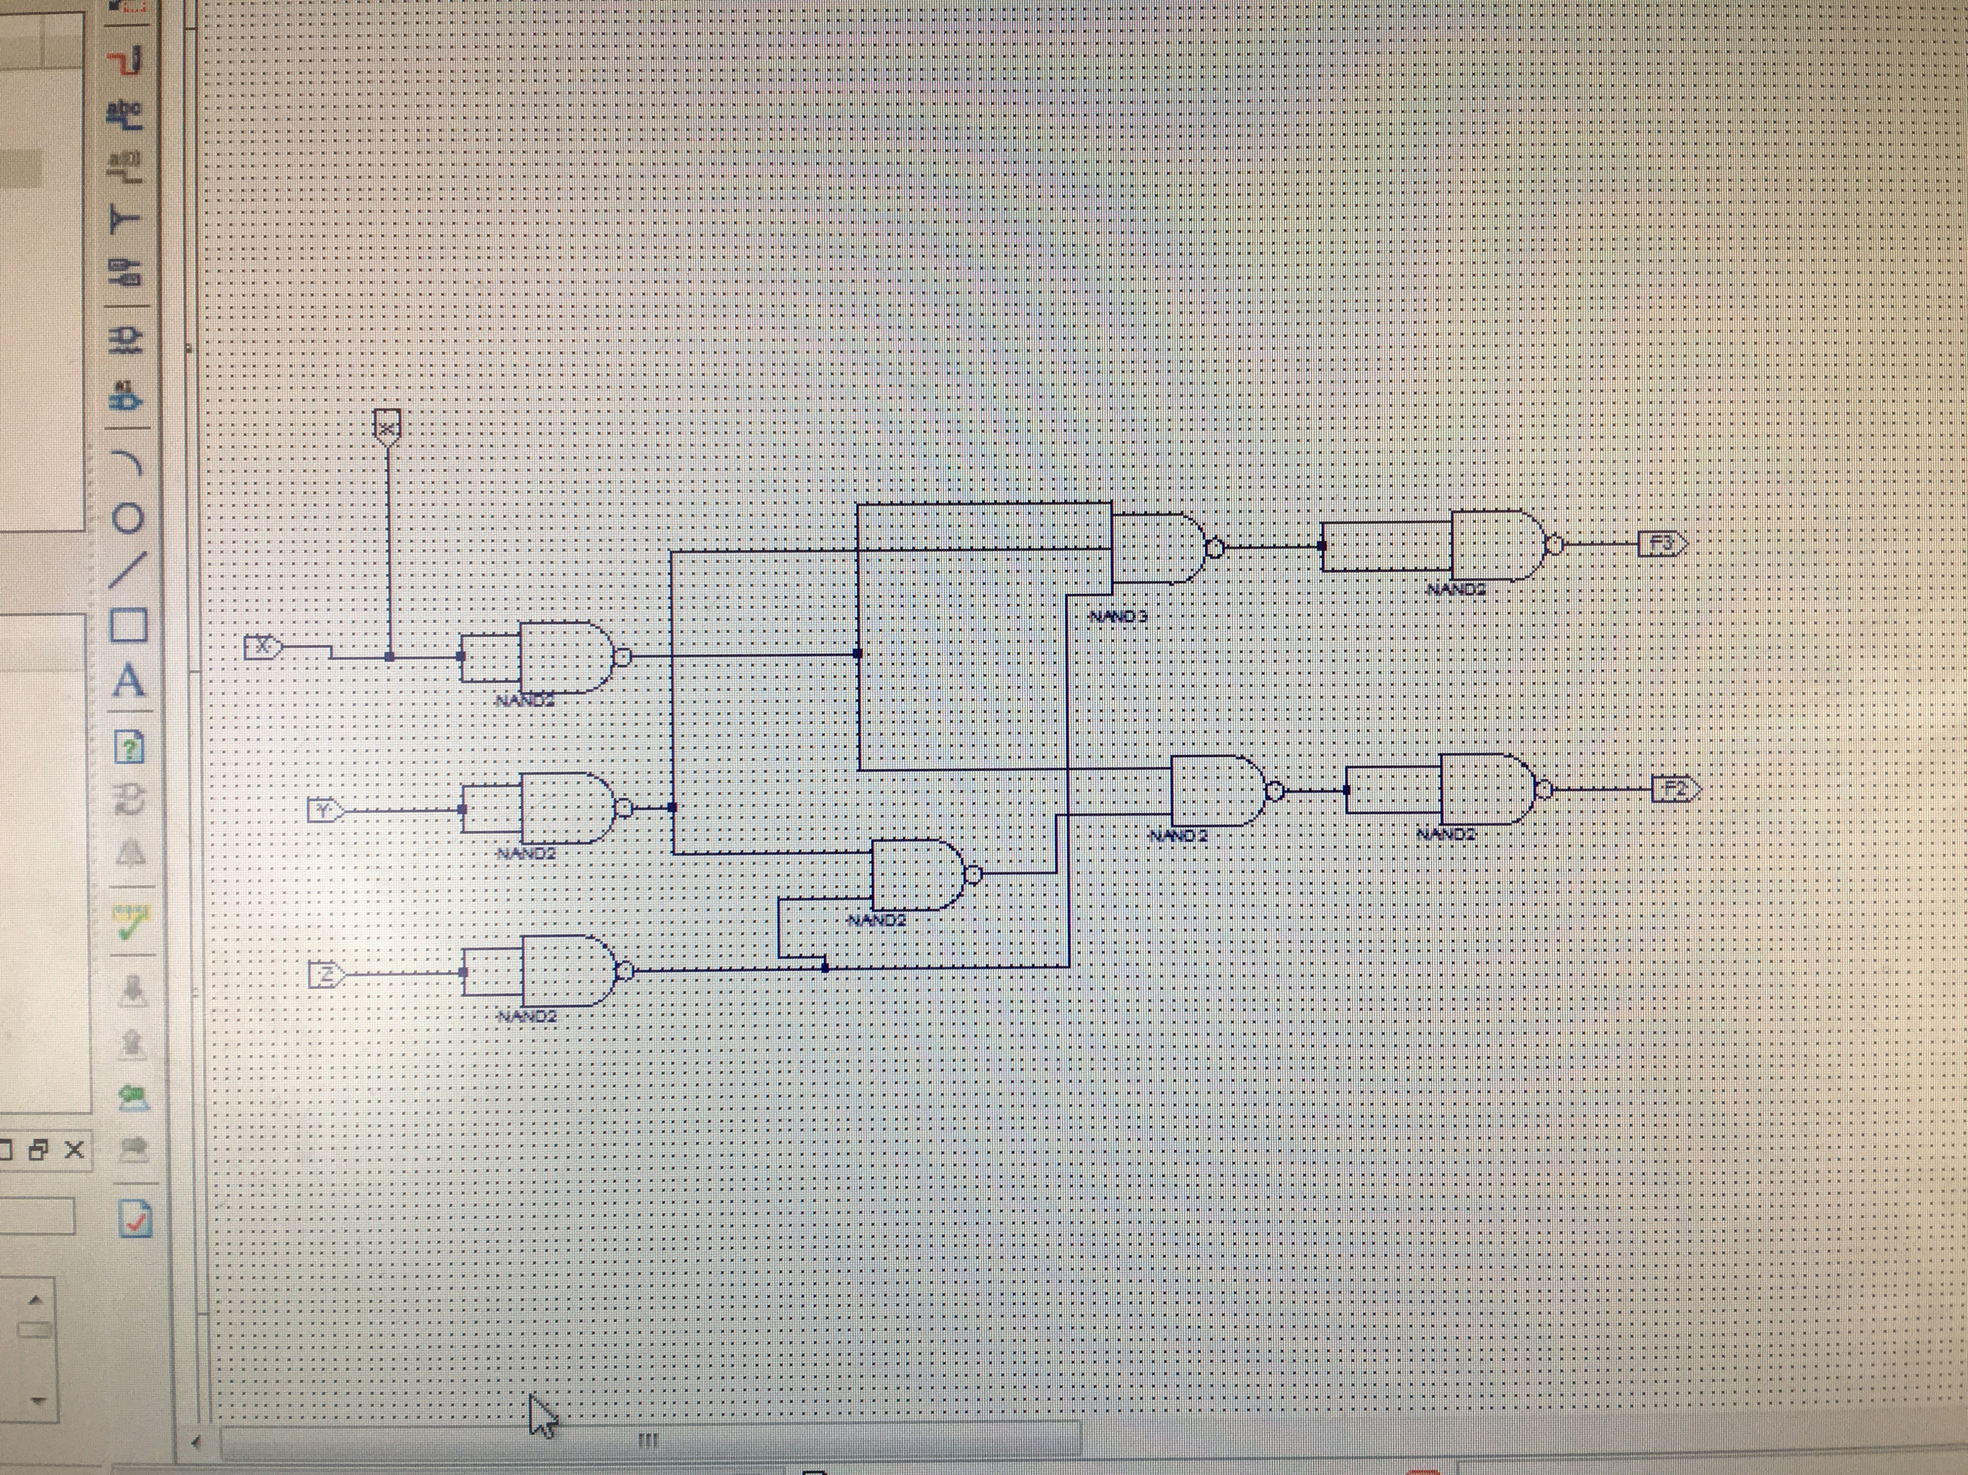

**Post lab and Conclusion**

This was a practical and useful lab in circuit design where we learn to implement circuits that can be used to perform useful tasks, such as turning a light on via the flip of anyone of 3 light switches. Another useful implementation would be to constructing a voting machine, to be used in a town meeting or perhaps a game show. The technique of coming up with a truth table or k-map for a stated problem or given equation is the first step to completing this task. After you have a simplified equation and therefor you know the cheapest route to building the desired circuit with the minimal amount of components necessary, then work in Xilinx can begin. You can construct your logic circuit and test it in Xilinx in order to save more money in future troubleshooting costs and hardware failure expenses that may arise from poor circuitry. A well designed and implemented circuit is one that is cost effective and efficient for the task it has been designed for. It is interesting to have reached a level of engineering where we can implement systems such as the sprinklers that we grew up watching work.







See page attached @ end of report

